Empowering Deaf and Hard-of-Hearing Women in Tanzania: A Campaign for Alternative Dispute Resolution (ADR) Awareness
6 month Report
Submitted by:
Erick Elizeus Mukiza
Court Certified Mediator
Executive Director, ESS Creative and Legal Foundation
Spring 2024 Professional Fellow (PFP)

Prepared for:
Stakeholders in Inclusive Justice

Date of Submission:
14th November 2024

Project Period:
June 2024 – November 2024

Report Description:
This report outlines the outcomes, impacts, and lessons learned from the campaign to raise awareness of Alternative Dispute Resolution (ADR) among Deaf and Hard-of-Hearing women in Tanzania. The project included resource development, training sessions, and participant story documentation to promote inclusivity and systemic change in conflict resolution practices.

1. Introduction
1.1 Overview of the Project
This project, led by Erick Elizeus Mukiza, a Court Certified Mediator and Spring 2024 PFP Fellow, focused on empowering Deaf and Hard-of-Hearing women in Tanzania by raising awareness about Alternative Dispute Resolution (ADR). ADR provides a faster, more affordable, and collaborative way to resolve disputes compared to traditional court litigation. However, Deaf individuals face significant barriers to accessing ADR due to communication challenges and a lack of reasonable accommodations.
The initiative addressed these gaps by developing inclusive resources, conducting training sessions, and documenting participants’ stories to foster broader awareness and systemic change.
2. Development of Training Materials
2.1 Inclusive Resources Developed
-Seven ADR Videos: Created in Swahili with closed captions and sign language interpretation to demonstrate the mediation process and benefits.
- Assistive Technology Integration: Use of CART (Communication Access Real-time Translation) for live transcription during sessions.
- Case Studies and Guides: Tailored materials highlighting real-life scenarios to help participants understand ADR in practical contexts.
2.2 Distribution Channels
These resources were distributed through ESS Creative and Legal Foundation’s platforms, FUWAVITA networks, and social media.
3. Purpose of the Training
The training aimed to equip Deaf and Hard-of-Hearing women leaders/entrepreneurs with ADR knowledge and skills, enabling them to resolve disputes effectively and advocate for justice within their communities.
4. Training Timeline
4.1 Key Dates
- June 17, 2024: Started to develop inclusive mediation videos in Swahili featuring sign language and closed captions.
- July 12, 2024: Official launch at the American Corner, National Museum in Dar es Salaam.
- September 24, 2024: Completion of inclusive mediation videos
- October 25, 2024: Two foundational training sessions at the High Court Mediation Centre.
- November 1, 2024: On-the-job training and story documentation at the FUWAVITA Center.
5. Training Objectives and Outcomes
5.1 Objectives
- Increase participants' understanding of ADR principles and benefits.
- Foster leadership among Deaf women through a train-the-trainer model.
- Advocate for systemic inclusion of people with disabilities in Tanzania’s legal framework.
5.2 Outcomes
- Participants developed a foundational understanding of ADR and its applications.
- A cascading effect was achieved as participants began training peers in their communities.
- Documented personal stories illustrated the transformative impact of ADR on individual and community levels.
6. Training Plan
6.1 Session 1: High Court Mediation Centre (October 25, 2024)
This foundational session covered:
- Types and benefits of ADR.
- Steps in the mediation process.
- The importance of confidentiality.
- Case studies of ADR application.
Facilitator: Judge Hon. Angela Bahati.
Duration:3 hours.

6.2 Session 2: High Court Mediation Centre (October 25, 2024)
This session covered:
- Role of technology in mediation.
- Ethical responsibilities of mediators and participants.
- Challenges and opportunities for Deaf individuals in mediation.
Facilitator: Judge Hon. Zahra Maruma.
Duration:3 hours.

6.3 Session 3: On-the-Job Training and Review (November 1, 2024)
Participants applied their knowledge by training colleagues and community members, supported by mentorship from Erick Mukiza and ESS staff. Personal stories of mediation experiences were also documented for advocacy purposes.
7. Knowledge Testing and Capacity Building
7.1 Assessment Methods
- Quizzes and Discussions: Evaluated participants' grasp of ADR concepts.
- Role-Playing Activities: Simulated mediation scenarios to develop practical skills.
- Ongoing Mentorship: Provided by judicial trainers and ESS staff to enhance participants’ confidence and expertise.
7.2 Sustainability Measures
Participants were encouraged to train others in their communities, ensuring sustainability through the cascading model.
8. Impact and Story Documentation
8.1 Participant Stories
Participants shared impactful stories, such as resolving disputes with suppliers or family members, showcasing the effectiveness of ADR.
8.2 Video Documentation
Training sessions and personal stories were recorded, edited, and shared with the High Court Mediation Centre, FUWAVITA, and on ESS's social media accounts.
8.3 Impact Measurement
As the 10 deaf and hard-of-hearing women initially trained went on to each train two additional members of the deaf community. This effectively tripled the reach of the program, expanding its impact from 10 participants to 30 empowered individuals, showcasing a cascading effect.
9. Group Discussion Assessments
9.1 Key Insights
- The importance of adopting assistive technologies like CART to enhance accessibility.
- Challenges faced by Deaf women in accessing mediation services and potential solutions.
- Participants’ enthusiasm for promoting ADR within their networks.
10. Trainer Remarks and Collaboration
10.1 Trainer Feedback
Trainers praised the project for its inclusivity and innovation.
10.2 Stakeholder Support
Senior High Court judges and stakeholders, including representatives from the Ministry of Constitutional and Legal Affairs, expressed strong support for integrating inclusive technology into broader judicial reforms.
11. Reflections and Lessons Learned
11.1 Successes
- I introduced CART to judges and senior judicial officers at the High Court Mediation Centre.
- Introduction of inclusive ADR training as a national first.
- Positive reception of ADR by deaf community and inclusive justice stakeholders.
- Development and dissemination of the first accessible ADR videos in the country.
11.2 Challenges
- Limited financial resources
- restricted training to urban areas.
- Ongoing advocacy is needed to embed inclusivity in Tanzania’s justice system.
11.3 Lessons Learned
Collaboration with stakeholders and innovative use of assistive technologies are critical for success.
12. Conclusion and Recommendations
12.1 Achievements
- 10 Deaf women leaders trained, now active as ADR advocates.
- Inclusive ADR videos developed and widely shared.
- Strengthened partnerships with government and disability organizations.
12.2 Recommendations
- Expand training to rural and underserved regions.
- Advocate for policy reforms to mandate inclusivity in mediation practices.
- Secure funding to sustain and scale the project.
12.3 Next Steps
- Establish mentorship programs to support trained women.
- Continue documenting and sharing success stories to inspire wider adoption of ADR.
- Develop additional resources tailored to specific community needs.

13. Photos and Visual Documentation
Inclusive ADR videos
A screenshot of inclusive video: a visual look at the inclusive ADR videos. They are in Swahili and featuring a sign language interpreter with closed captions | 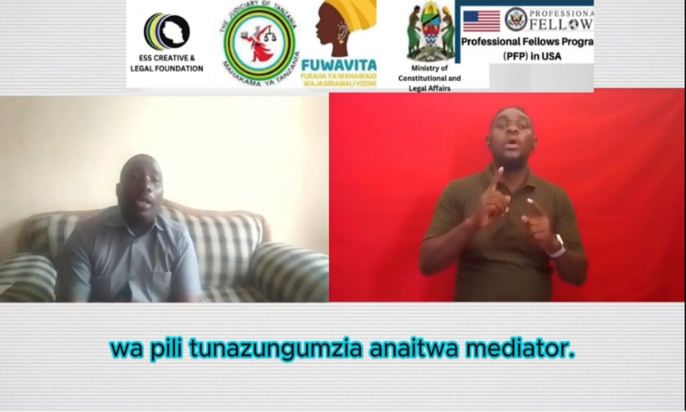
Project launch event
Hon. Mary Gaspar Makondo, Aneth Gerana, Erick Mukiza, ESS Board members and the deaf women from FUWAVITA during the project launch | 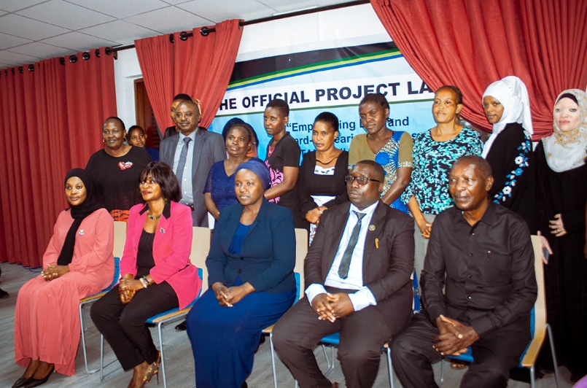
Picture shows Seating arrangement during the project launch of C-shaped classroom. An inclusive environment for deaf persons | 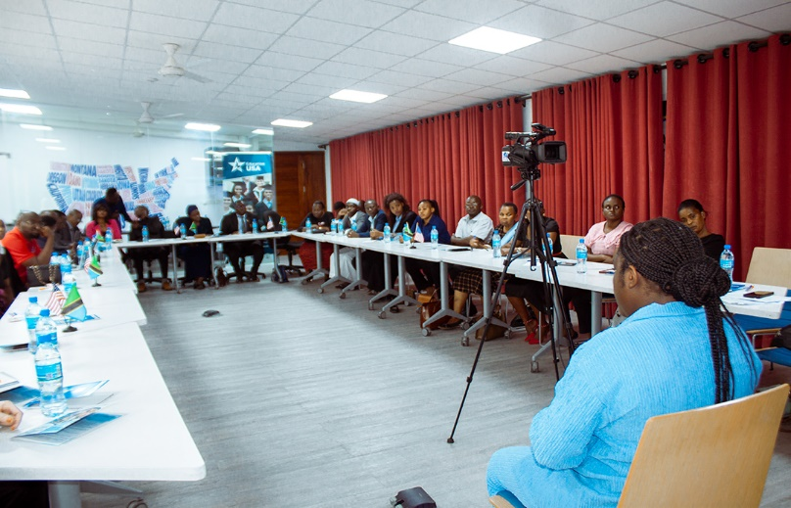
Project Launch by the Guest of Honor: Hon. Mary Gaspar Makondo, the permanent Secretary of the Ministry of Constitutional And Legal Affairs. | 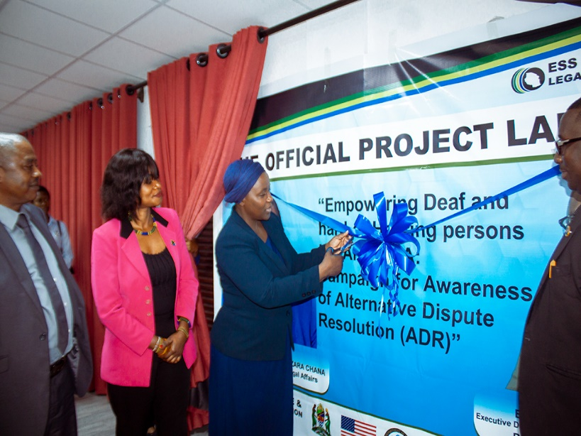
Training sessions at High Court Mediation Center
The Judge of the Center, Hon. Angela Bahati, delivering a presentation on the importance of using mediation to resolve conflicts. | 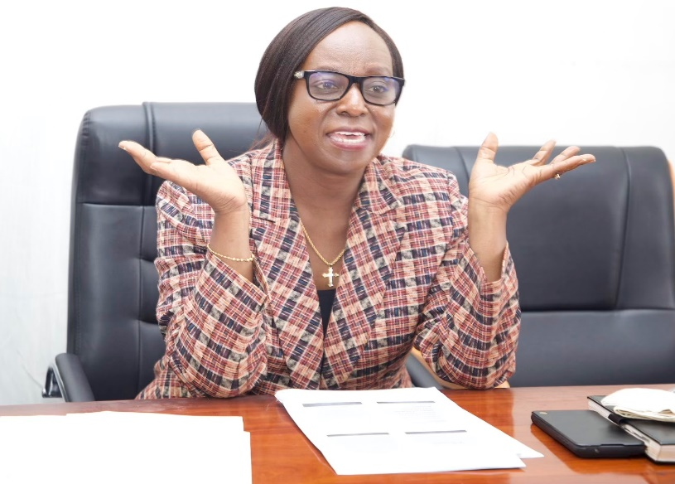
The Judge in Charge of the Mediation Center, Hon. Zahra Maruma, delivered a presentation on the importance of using mediation to resolve conflicts and the role of this technology during the training session. | 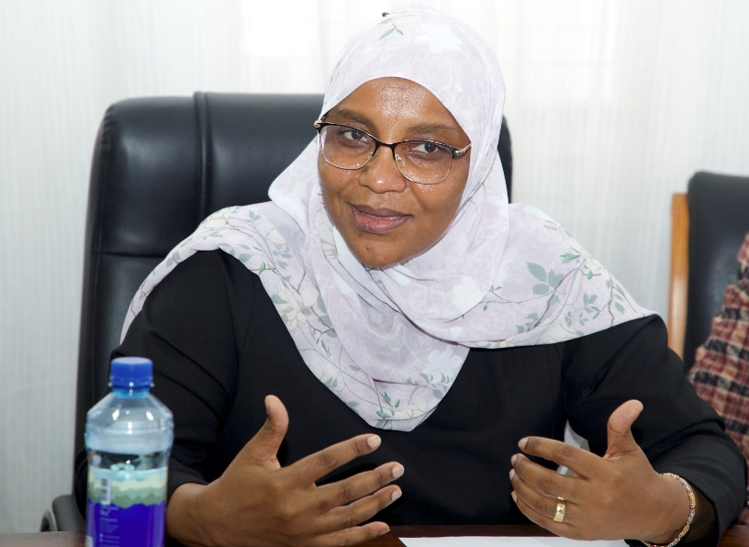
The CART technology converted spoken words into displayed text on screen during the training | 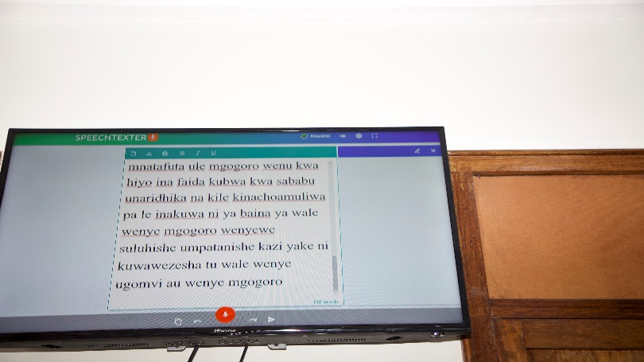
The Judge in Charge of the Mediation Center, Hon. Zahra Maruma (left), presenting a certificate to a participant in the training, Ms. Leah Kyejo. | 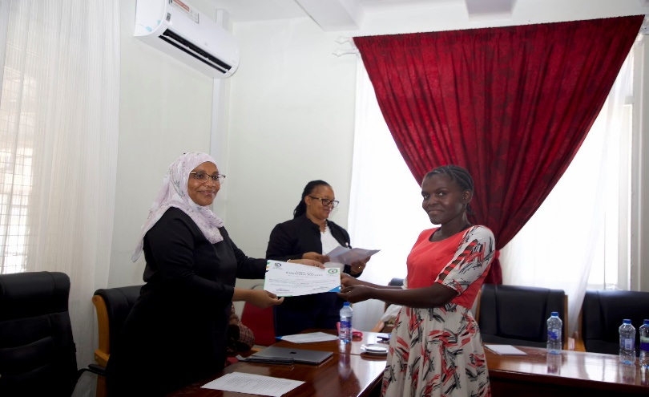
High Court Judge, Hon. Arufani Kweka (left) giving closing remarks | 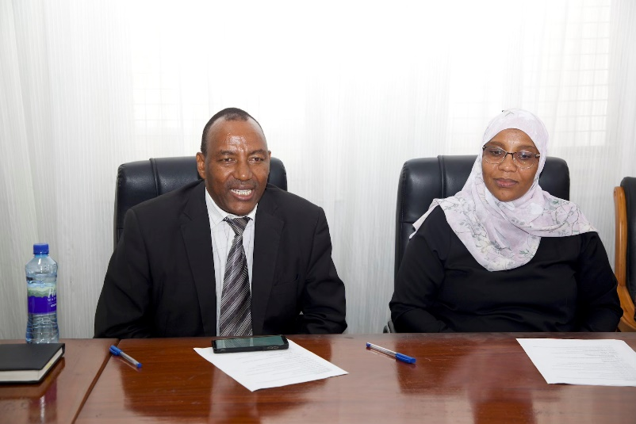
The main table in a group photo with the training participants, including other Center staff, raising their hands in celebration. | 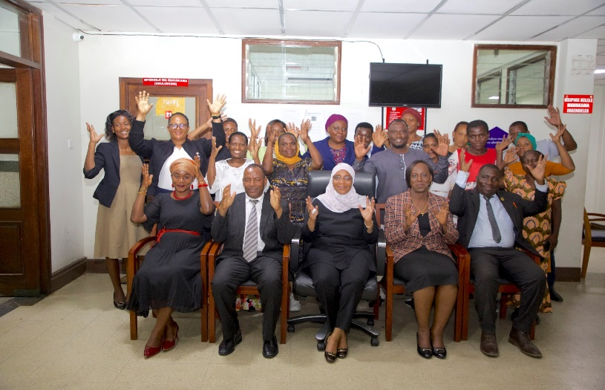
On-job training and review session at FUWAVITA center
The trained ladies observing Bosco Monna the sign language interpreter | 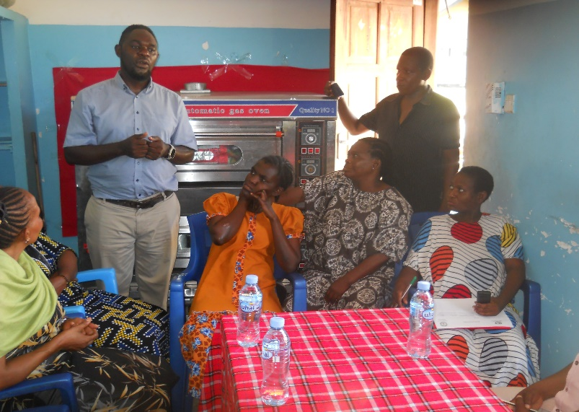
One of the deaf entrepreneur showing her product during on-the job training and review session | 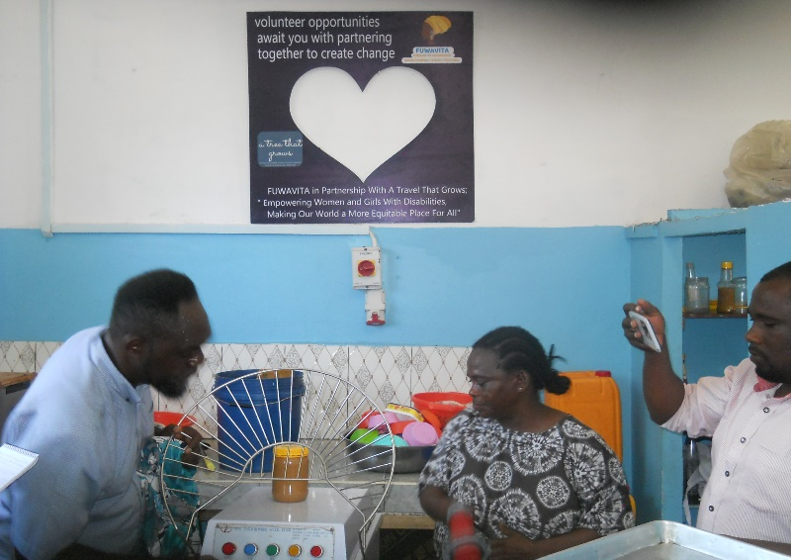
A deaf leader explaining what she learnt about mediation to the colleagues | 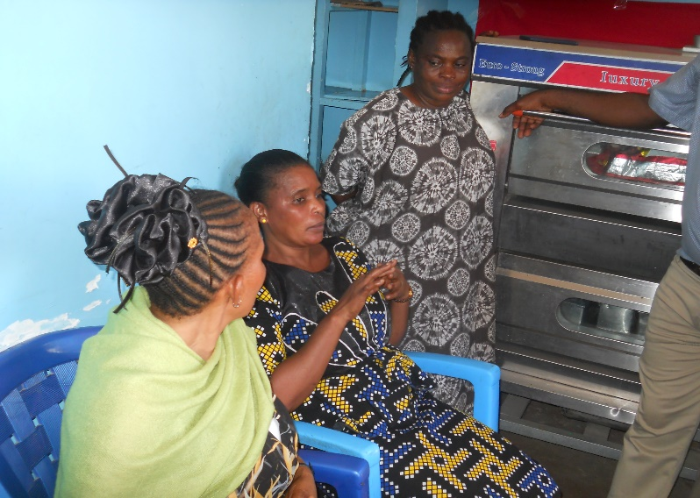
A hard of hearing member of FUWAVITA explaining her products to Erick Mukiza and his team during the on-the-job training and review session | 